Auto 0 – Tote and Container.

Start robot positioned at any three locations with Container in arms, and elevator down. Finishes with RC on top of Tote.

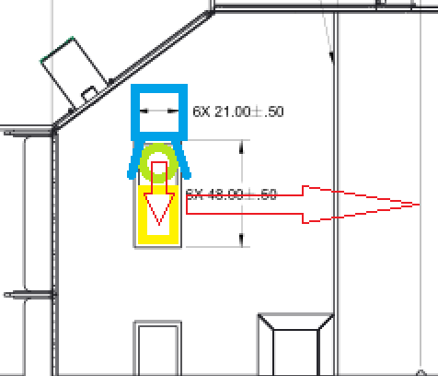

Auto 1 = Drive Straight from Starting

Start anywhere centerline of the bot, approximately equal to the centerline of the totes in staging area.

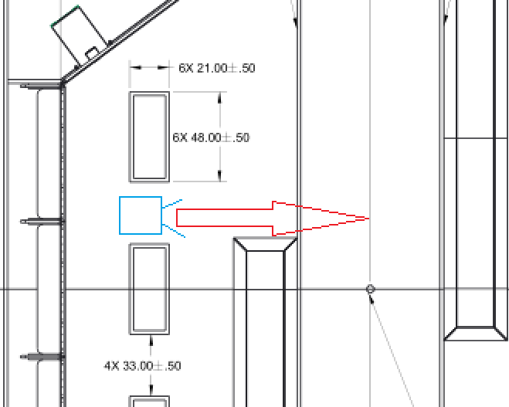

Auto 2 = Drive straight from Voldermont

Start anywhere in Voldermont Zone (The Zone that cannot be named), back close to edge of totes in landfill.

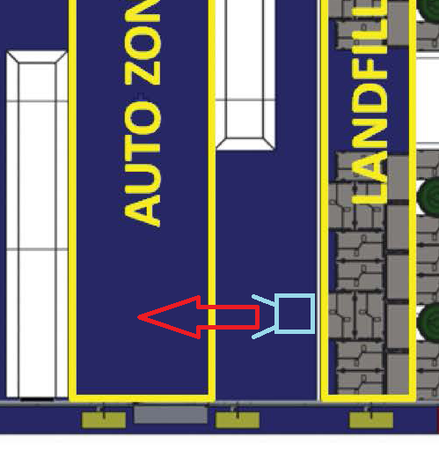

Auto 3 = 2 Container Left Turn

Start with totes off field, bot with container in arms, two locations possible.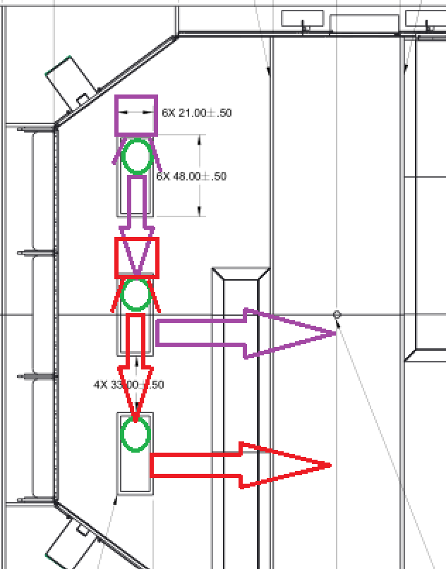

Auto 4 = 2 Container Right Turn

Start with Totes off field, bot with container in arms, two locations possible, where totes usually sit.

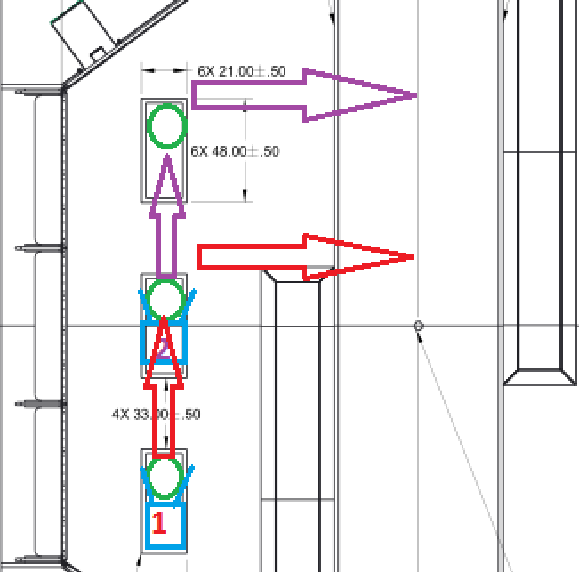

Auto 5 = Do Nothing.

Start anywhere, stays where set.

Auto 6 = Tape Measure

Start in Voldermont Zone (The Zone that cannot be named), back close to edge of totes in landfill. Extend tape measure out to hole in container to ensure alignment. When returning the tape measure leave the 4” mark flush with the end of the tape measure frame.

